COVAI ZONE CIVIL ENGINEERS ASSOCIATION (COZCENA)
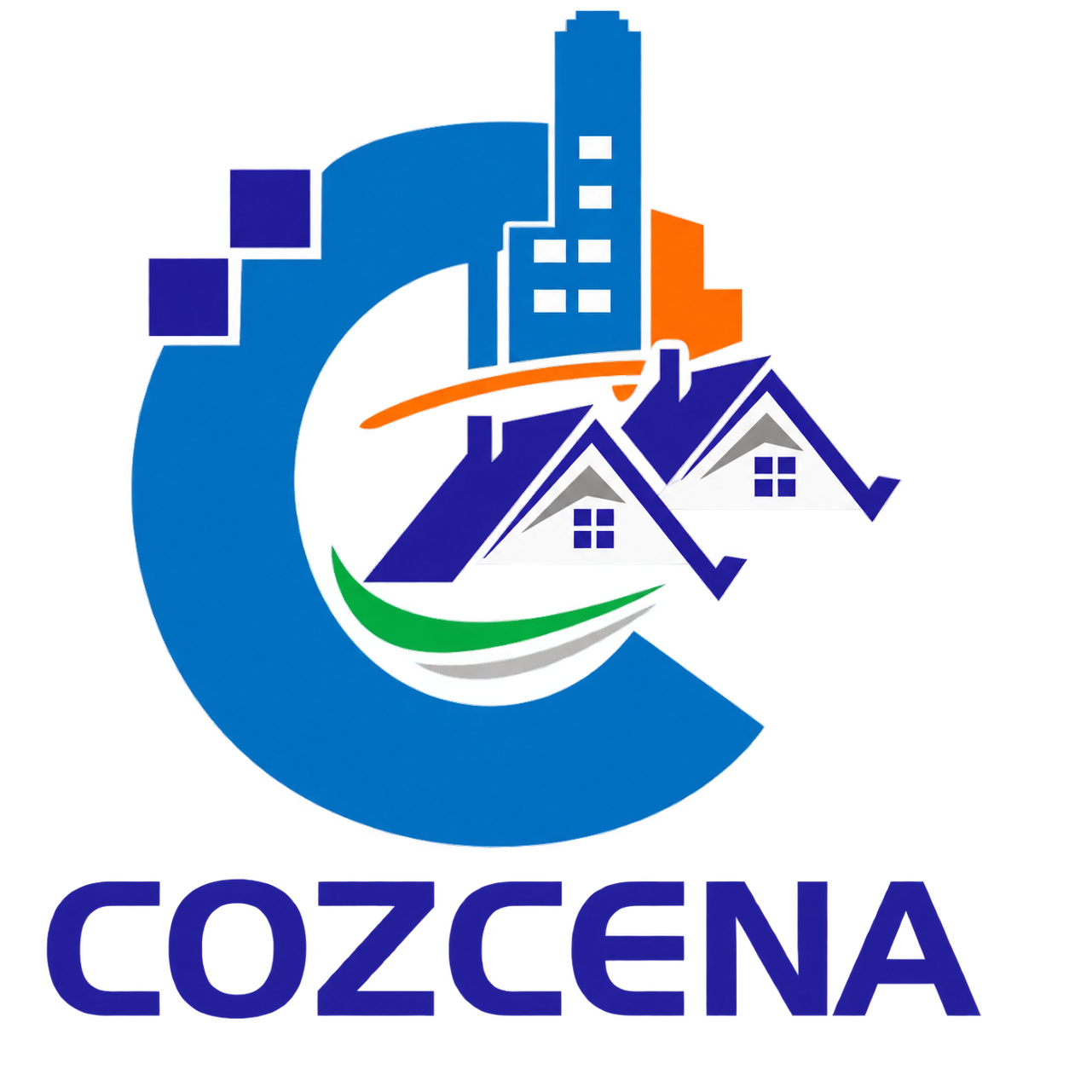
COZCENA ENGINEERING EXCELLENCE AWARDS – 2026
YOUNG ENGINEER AWARD
This award recognises a promising young Civil Engineer who has demonstrated noteworthy professional or academic achievement, technical competence, innovation, emerging leadership, ethical practice and meaningful contribution to Civil Engineering and society.
ELIGIBILITY / GENERAL CONDITIONS
- Open to Civil Engineers engaged in professional practice, consultancy, construction, research, academics, entrepreneurship or allied Civil Engineering activities.
- Recommended age criterion: 35 years or below as on 15 September 2026, subject to confirmation in COZCENA’s final award notification.
- Applications may be submitted by the nominee or through nomination.
- Achievements should demonstrate individual contribution, innovation, leadership potential and professional impact.
APPLICATION / NOMINATION TYPE
☐ Self Application ☐ Nomination by Institution / Organisation ☐ Nomination by Professional Peer / Association
DETAILS OF THE NOMINEE
Full Name | Dr. / Er. / Prof. / Mr. / Ms. …
Date of Birth | DD / MM / YYYY
Age | Years
Highest Qualification
Present Designation
Institution / Organisation / Firm
Total Experience | Years
Area(s) of Specialisation
Professional Memberships / Registrations
Postal Address
Mobile Number
Email Address
NOMINATOR DETAILS (IF APPLICABLE)
Name of Nominator
Designation
Organisation
Mobile Number
Email Address
Professional Relationship with Nominee
PROFESSIONAL PROFILE
Provide a concise professional profile highlighting career progression, present responsibilities and major areas of contribution. (Recommended 250–300 words)
KEY PROJECTS / CONTRIBUTIONS
Sl. No. | Project / Contribution | Role | Outcome / Impact
PROFESSIONAL / ACADEMIC ACHIEVEMENT
Describe noteworthy achievements in practice, consultancy, construction, research, academics, entrepreneurship or allied Civil Engineering activities.
INNOVATION & TECHNICAL CONTRIBUTION
Describe innovative solutions, designs, research, technologies, digital tools, materials, start-up initiatives, patents or technical improvements introduced.
EMERGING LEADERSHIP & PROFESSIONAL INVOLVEMENT
Describe leadership roles, team responsibilities, professional association involvement, technical events, volunteering and initiatives led.
SUSTAINABILITY & SOCIETAL CONTRIBUTION
Describe work related to sustainable engineering, climate resilience, community benefit, public safety or responsible professional practice.
KNOWLEDGE SHARING & MENTORING
Describe contributions to mentoring peers / students, technical talks, workshops, publications, social outreach or knowledge-sharing.
FUTURE VISION
Briefly state your professional vision and how you intend to contribute to the future of Civil Engineering. (Recommended 150–200 words)
THREE MOST OUTSTANDING ACHIEVEMENTS
Achievement 1: State the achievement, your specific role and its measurable / lasting impact.
Achievement 2: State the achievement, your specific role and its measurable / lasting impact.
Achievement 3: State the achievement, your specific role and its measurable / lasting impact.
AWARDS / HONOURS / PROFESSIONAL RECOGNITION
Sl. No. | Award / Recognition | Awarding Organisation | Year
AWARD CITATION
Provide a concise citation explaining why the nominee deserves the YOUNG ENGINEER AWARD. (Maximum 200 words)
SUPPORTING DOCUMENTS CHECKLIST
☐ Recent passport-size photograph
☐ Curriculum Vitae / professional profile
☐ Evidence of qualifications and professional registrations, where relevant
☐ Evidence supporting major projects / academic contributions / innovations
☐ Copies or details of major awards and recognitions
☐ Selected publications / patents / technical outputs, where applicable
☐ Any other document supporting the nomination
DECLARATION BY THE NOMINEE
I hereby declare that the information furnished in this application for the YOUNG ENGINEER AWARD and in the supporting documents is true and correct to the best of my knowledge. I authorise COZCENA to verify the information submitted and understand that the decision of the Award Selection Committee shall be final.
Place: | Date:
Signature of Nominee: | Name of Nominee:

AWARD COMMITTEE SCORE SHEET - FOR COZCENA OFFICE USE ONLY
Application No.
Date Received
Eligibility Verified | ☐ Yes ☐ No
Shortlisted | ☐ Yes ☐ No
Final Recommendation | ☐ Recommended ☐ Not Recommended ☐ Wait-list
Evaluation Matrix
Criterion | Maximum Marks | Marks Awarded
Professional / Academic Achievement | 20
Technical Competence & Engineering Excellence | 20
Innovation & Problem-Solving | 20
Leadership & Professional Involvement | 15
Sustainability / Societal Contribution | 10
Knowledge Sharing & Mentoring | 5
Future Potential & Overall Impact | 10
TOTAL | 100
Committee Comments / Justification
Evaluator / Committee Member 1:  Signature: | Evaluator / Committee Member 2:  Signature:
Award Committee Convenor:  Signature: | Date:

